

**DEPARTMENT OF CIVIL ENGINEERING**

**SHC 798**

**APPLIED STATISTICAL METHODS AND OPTIMISATION**

**Multiple Linear Regression & ANOVA**

**RICHARD LUBEGA**

*Full names*

**25585089**

*Student number*

**2**

*Assignment*

# DECLARATION

1. I understand what plagiarism is and am aware of the University’s policy in this regard.
2. I declare that this submission is my original work. Wherever other people’s work has been used (either from a printed source, the internet or any other source) this has been properly acknowledged and referenced in accordance with departmental requirements.
3. I declare that I have used AI-based tools (*ChatGPT*, *Grok* and *Manus*) to help interpret and debug my R code for attempting the assignment questions.
4. I have not used another student’s current or past written work to hand in as my own.
5. I have not allowed and will not allow anyone to copy my work to pass it off as his or her work.

Signature: 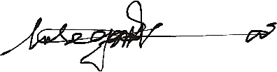

Date: 06-10-2025

# TABLE OF CONTENTS

DECLARATION 1

TABLE OF CONTENTS 2

1 Part 1: Multiple Linear Analysis (MLR) 3

1.1 Question 1 3

1.1.1 Part a): Data Preparation 3

1.1.2 Part b): Multicollinearity 5

1.1.3 Part c) Model Output 7

1.1.4 Part c): Variable Selection 10

1.1.5 Part d): 5-fold Cross Validation & MSPE 14

1.1.6 Part e): Prediction 16

1.2 .Question 2 17

1.2.1 Part a): Multicollinearity 18

1.2.2 Part b): Model and Predictor Linearity 19

1.2.3 Part c): Variable Selection 29

1.2.4 Part d): 5-fold cross-validation & MSPE 33

1.3 Question 3 35

1.3.1 Q 3.1: MCQ Answer 35

1.3.2 Q 3.2: MCQ Answer 35

2 Part 2: Analysis of Variance (ANOVA) 36

2.1 Question 4 36

2.1.1 Part a): Box Plots 37

2.1.2 Part b): A one-way ANOVA test 38

2.1.3 Part c): A pairwise two-sample t-test 39

2.1.4 Part d): Residual Diagnostics 40

2.2 Question 5 42

2.2.1 Part a): Box Plots 42

2.2.2 Part b): A two-sample t-test 44

2.2.3 Part c): Test statistic, p-value, and conclusion 44

2.2.4 Part d): Practical significance 45

2.3 Question 6 46

2.3.1 Q 6.1 MCQ Answer 46

2.3.2 Q 6.2 MCQ Answer 46

2.3.3 Q.6.3 MCQ Answer 46

2.3.4 Q6.4 MCQ Answer 46

# Part 1: Multiple Linear Analysis (MLR)

## Question 1

Concrete Strength Data

### Part a): Data Preparation

1. Histograms and Marginal Distributions

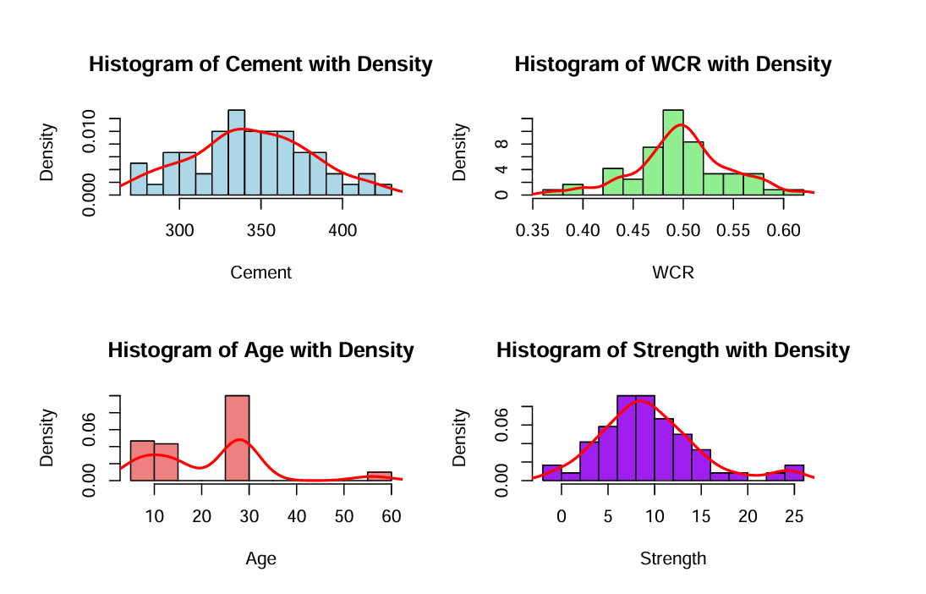

1. Scatter Plots

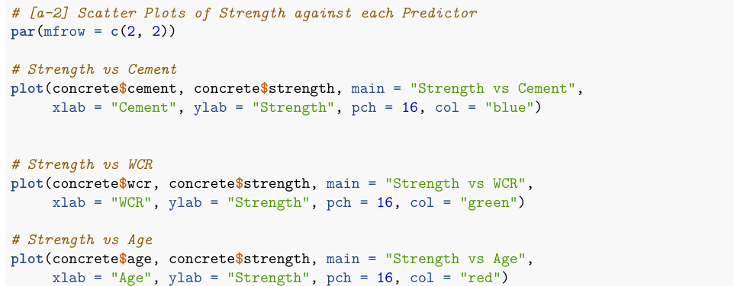

**Commenting on the Trend and Need for Variable Transformation**

The marginal plots are not skewed and there is no warranted need for variable transformations.

The scatter plot for strength vs age indicates has distinct values (7, 14, 28, 56) which suggests a discrete or categorical nature rather than continuous. The marginal plots for age also show spikes at these specific ages rather than a smooth distribution.

Therefore, age may be as a categorical variable (factor) in regression to account for its discrete levels. Including *interaction terms* (e.g., cement:age, wcr:age) in such a regression model may be also necessary.

### Part b): Multicollinearity

#### Pearson correlation coefficients

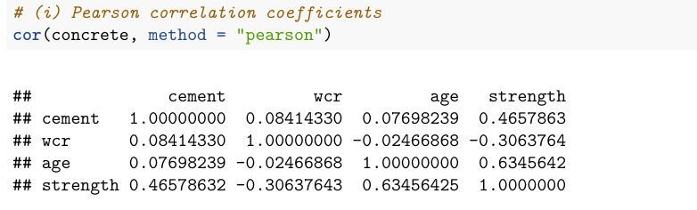

#### Ellipse plot to visualise collinearity

#### Variance Inflation Factors (VIFs)

**Comment on the findings**

From the above collinearity audit checks (Pearson correlation coefficients and the ellipse plot), the somewhat elongated ellipses, particularly between strength and cement (0.46578632), and strength and age (0.6345642), suggest potential multicollinearity among these predictors.

This indicates that these predictors may be highly correlated with each other and with the response variable, but Since all VIF values are very close to 1 (well below 5), there is no significant multicollinearity among the predictors. This suggests that the predictors are largely independent of each other, which is ideal for a stable regression model.

### Part c) Model Output

#### Multiple Regression Model

The Model [conc_model]: strength ∼ cement + wcr + age

#### Model Output, Adequacy & Appropriateness of Fit

1. **Regression Coefficients**

The **slope** coefficients (cement: 0.06657, wcr: -37.44811, and age: 0.26614) indicate the respective change (increase [+] or decrease [-]) in the concrete strength when each of the predictors increase by 1 unit, but all other predictors remain unchanged.

* The p-values in summary(conc_model) determine whether the different response-predictor relationships are statistically significant. The p-value are all below 0.05, so we reject the null hypothesis on a 5% significance level and conclude that all the variables (cement, wcr, and age) significantly affect concrete strength. A zero slope coefficient is implausible for all the predictors.

The **intercept** coefficient corresponds to the estimated (theoretical) concrete strength value when all the predictors (cement, wcr, and age) are equal to zero.

* It’s p-value (0.942) is not statistically significant at the 5% level, and an intercept of zero is plausible.
* However, interpreting this is not practically rational but ensures the regression hyperplane fits the data best within the observed predictor values range. It is not meaningful to extrapolate the predictors to zero.

1. **Model Significance**

From the summary (the global F-Statistic), we gather that p-value is very small (4.441e-14) and that the model is highly significant at the 5% level.

1. **Appropriateness of Fit [Model Diagnostics]**

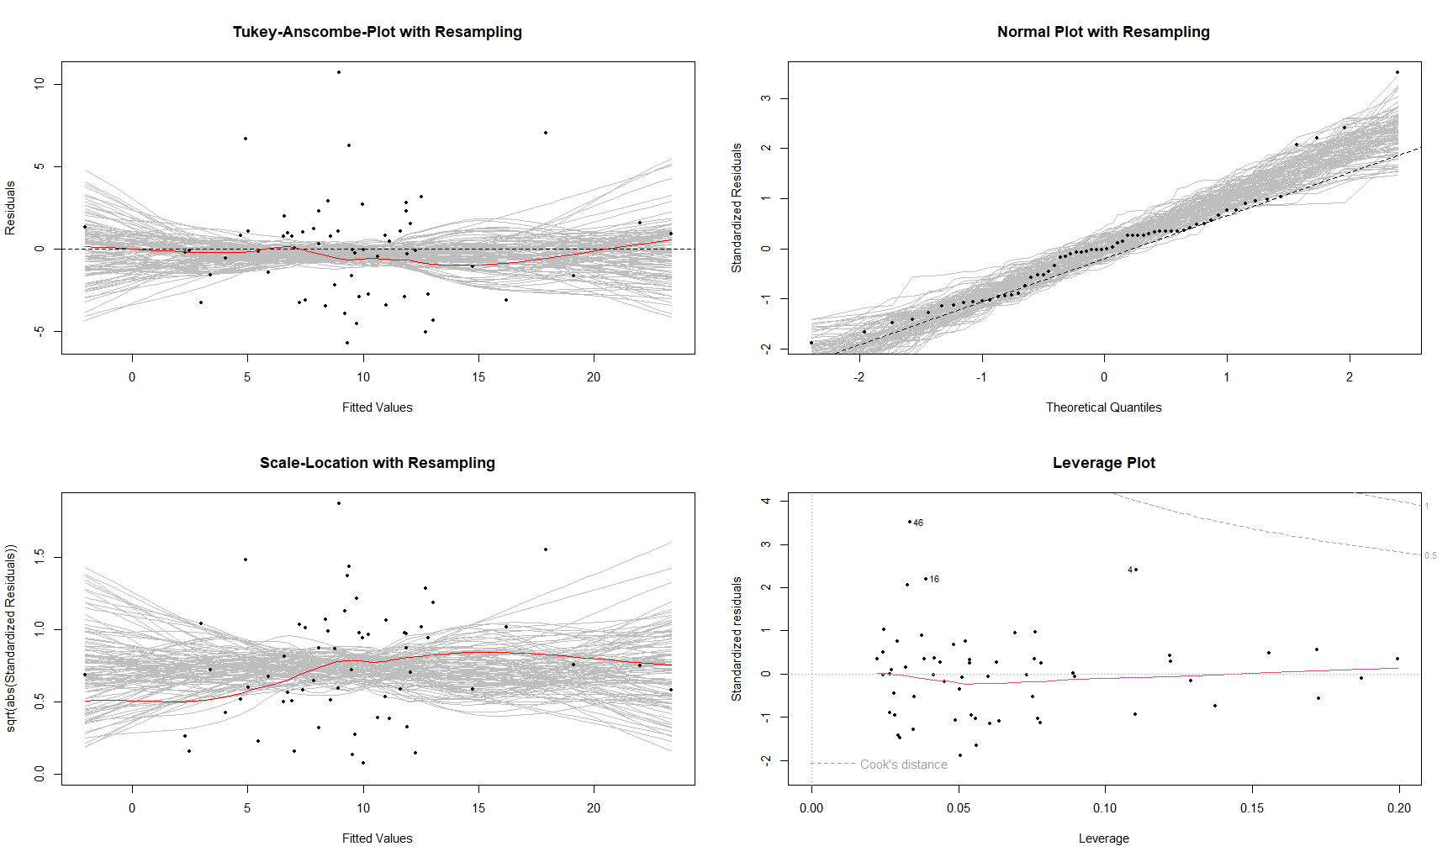

1. **Linearity: E [*Ei*] = 0**

The Tukey-Anscombe residual plot shows that the smoother does not deviate from the x-axis except for a slight kink for fitted values between 10 and 20 but this deviation can be attributed to randomness. Using the resampling approach by the R function, resplot(), the original red smoother is within what can be generated by random sampling. It is thus imperative to that we accept the linearity hypothesis E [*Ei*] = 0.

Hence, there is no systematic error and the hyperplane is the correct fit.

1. **Homoskedasticity, Var (*Ei*) = *σ2E***

From the Scale-Location plot, the red smoother is generally horizontal with a gentle kink (between 5 and 17 of the fitted values) which can be considered random. Using the resampling approach, the smoother line is well within the confidence region. We can consider that there is no heteroscedasticity.

1. **No Correlation: Cov (*Ei****,* ***Ej*) = 0**

Since the concrete dataset observations are not directly affected by temporal variation (in the age variable), the errors may be autocorrelated. The Durbin-Watson test run to check this.

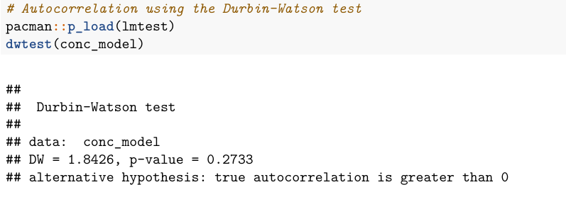

The Durbin-Watson statistic (1.8426) is close to 2 and the high p-value (0.2733) implies that the small deviation from 2 could easily be due to random chance. Thus, Meaning: we fail to reject the null hypothesis of positive autocorrelation in residuals. There is no statistically significant evidence of autocorrelation in the residuals of the model.

The residuals may be considered independent and uncorrelated.

1. **Normality: *Ei* ∼ N(0,*σ2E*)**

From the Normal Q-Q Plot, the bulk of the residuals (largely in the central region) are approximately Gaussian distributed. A noticeable deviation (3 outliers) at the upper tail indicates right skewness and departure from normality but because all residuals from the concrete dataset fall within the resampling based confidence region, there is no systematic deviation from the normal distribution. Therefore, the *i.i.d.* assumption holds.

1. **Adequacy of Fit [**R2**]**

The R-squared from summary (conc_model) indicates how much variation in concrete strength is explained by the three predictors as per the regression hyperplane. Here, multiple R2 = 0.6852 (the adjusted R2 = 0.6684), meaning that 69% of the variation in concrete strength is explained by predictors (cement, wcr, and age), while the remaining 31% is due to other factors not included in the model.

**Summary**: From the R2 value (0.6852), the regression model (hyperplane) is **adequate** because it accounts for a large portion of the total variation in the concrete strength. The model is also **appropriate** because of the good model diagnostics.

### Part c): Variable Selection

Starting from the initial (conc_model).

1. **Backward Elimination Model** (conc.back)



1. Forward Selection **Model** (conc.forw)

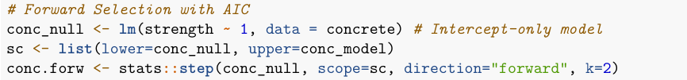

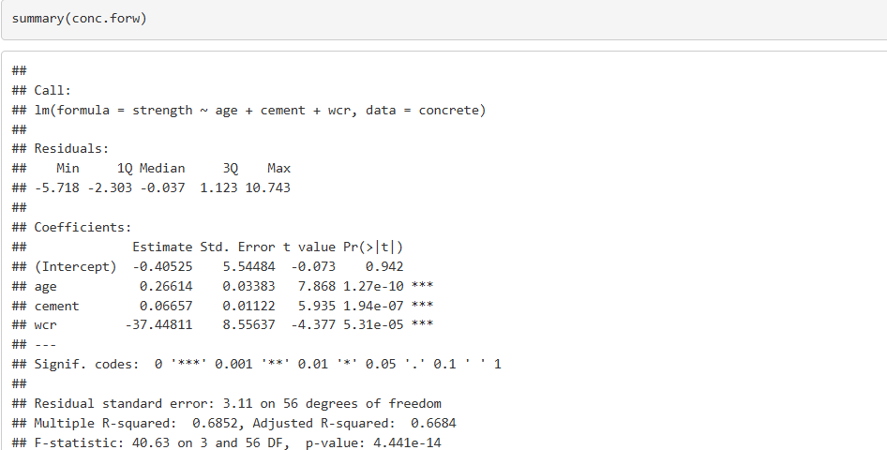

1. AIC Stepwise **Models** [conc.b1, conc.b2, and conc.b3]



**Models** conc.b1

**Models** conc.b2

**Models** conc.b3

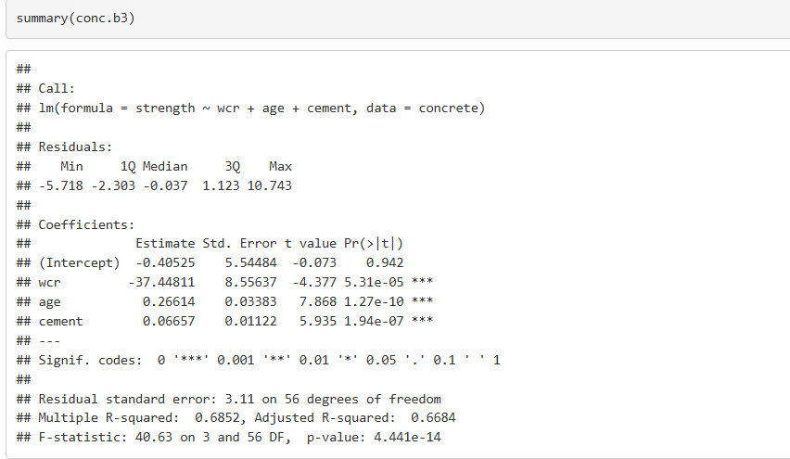

Residual plots for conc.forw



**Commenting on Variable Selection Results**

For all the variable selection methods, all the 3 predictor variables (cement, wcr, and age) are retained in all the 6 models (the initial model and the 5 test models).

There are no also major improvements in residual plots for all the models (residual plots for model conc.forw are shown above). Also, there is no noticeable changes on predictor significance or model fit.

Therefore, I would recommend the initial model (conc_model) before variable selection was conducted.

### Part d): 5-fold Cross Validation & MSPE

**The 5-fold cross-validation loop code**

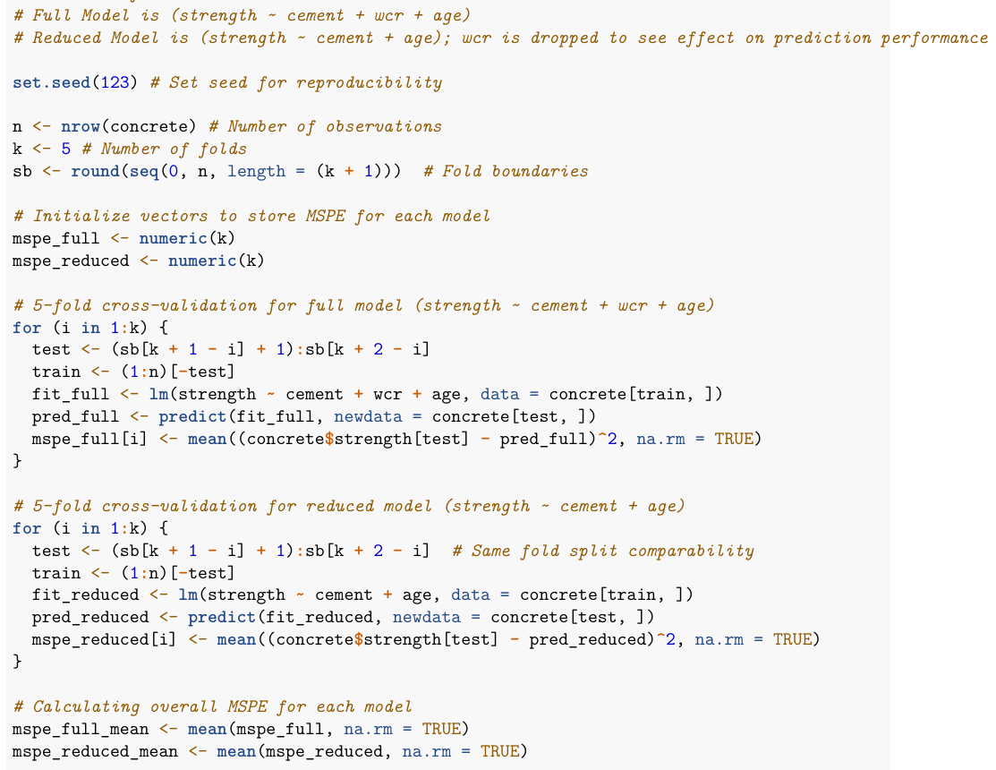

**MSPE values** for both the full and reduced models

* Full Model



* Reduced Model



Comparing change in MSPEs (Full to Reduced)



**Visualising MSPEs** with Box Plots

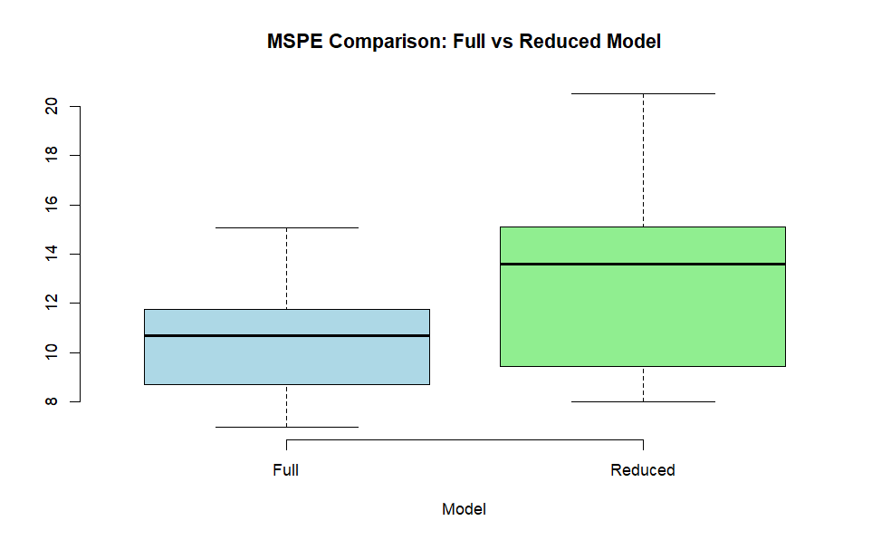

**Comparing the models**

From the cross-validation exercise above, The MSPE for the reduced model is substantially higher (25.29973%) than the full model. Therefore, the variable, wcr, adds predictive power and the full model is preferable for prediction purposes.

The full model with the variable, wcr, is therefore recommended.

### Part e): Prediction

The model predicts a mean of 11.62271 MPa. The prediction interval spans over 12.6 MPa (from 5.324389 to 17.92103) which reflects high variability in strength for a single batch given the inputs. For structural design, this constitutes a very large uncertainty and the mix may not consistently meet design requirements.

Practically, this result is not fully reliable for decision-making about a specific batch without further testing or improving the model.

## .Question 2

Energy consumption data from 80 office buildings

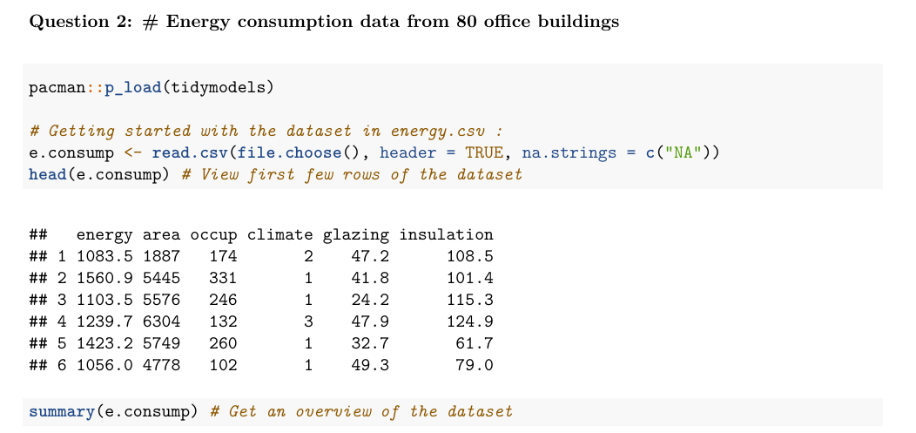

### Part a): Multicollinearity

#### Pearson correlation coefficients

#### Ellipse plot to visualise collinearity

#### Variance Inflation Factors (VIFs)

**Commenting on Multicollinearity**

In the correlogram (ellipse plot), narrow/elongated ellipses indicate stronger correlation. Energy has elongated ellipses with area (0.5672719) and occupancy (0.71535501), indicating moderate to strong positive correlation. Also, area and occupancy are noticeably correlated with narrow tilted ellipse (0.60076867) which indicates collinearity. Therefore, there is some multicollinearity between area and occupancy, and to a lesser extent between energy and these two variables.

Since all VIF values are very well below 5, there is no significant multicollinearity among the predictors for the model, engy_model. This suggests that the predictors can be considered independent of each other for this regression model.

### Part b): Model and Predictor Linearity

#### Initial Model Output, Adequacy & Appropriateness of Fit

**Multiple Regression Model**

The model is [energy ~ area + occup + climate + glazing + insulation]

1. **Regression Coefficients**

The **slope** coefficients in the engy_model summary above indicate the respective change (increase [+] or decrease [-]) in energy consumption when each of the predictors increase by 1 unit while all other predictors remain unchanged.

* The p-values determine whether the different response-predictor relationships are statistically significant. Only 3 predictors (area, occup, and insulation) have p-values are all below 0.05 (where we reject the null hypothesis on a 5% significance level) Therefore, these variables significantly affect energy consumption. A zero slope coefficient is plausible for the other predictors (climate and glazing). Hence, they likely do not affect energy consumption

The **intercept** coefficient corresponds to the estimated (theoretical) energy consumption value when all the predictors are equal to zero.

* It’s p-value (8.23e-12) is statistically significant at the 5% level, and an intercept of zero is not plausible.
* Although interpreting this is not practically rational, it ensures the regression hyperplane fits the data best within the observed predictor values range. It is not meaningful to extrapolate the predictors to zero.

1. **Model Significance**

From the summary (the global F-Statistic), we gather that p-value is very small (1.101e-13) and that the model is significant at the 5% level.

1. **Adequacy of Fit [**R2**]**

The R-squared from summary (engy_model) indicates how much variation in energy consumption is explained by the five predictors as per the regression hyperplane. Here, multiple R2 = 0.6042, (the adjusted R2 = 0.5774), meaning that 61% of the variation in energy consumption is explained by predictors (area, occup, climate, glazing, and insulation), while the remaining 39% is due to other factors not included in the model.

1. **Appropriateness of Fit [Model Diagnostics]**

Residual Plots

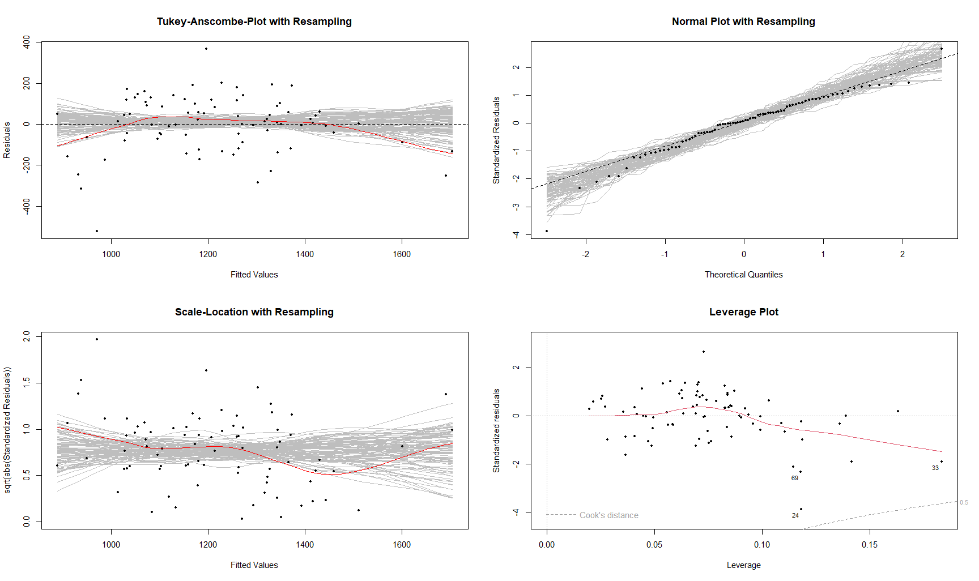

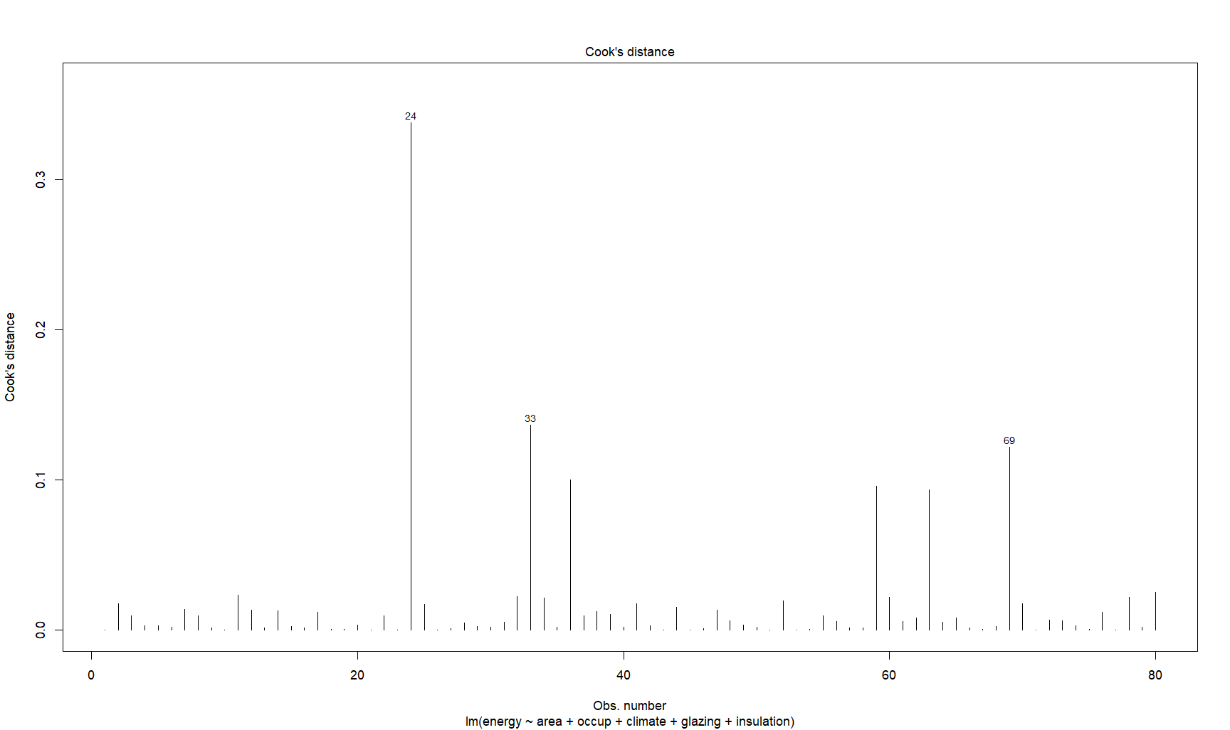

1. **Linearity: E [*Ei*] = 0**

The Tukey-Anscombe residual plot shows that the smoother noticeably deviates from the x-axis at low and high fitted values. From the resampling approach by the R function, resplot(), this deviation may be attributed to randomness because the original red smoother is within what can be generated by random sampling. We accept the linearity assumption.

1. **Homoskedasticity, Var (*Ei*) = *σ2E***

From the Scale-Location plot, the red smoother is generally horizontal and the slight kink (between 1400 and 1600 of the fitted values) can be considered random because the smoother line is well within the resampling confidence region. There is no worrying heteroscedasticity.

1. **No Correlation: Cov (*Ei****,* ***Ej*) = 0**

The energy dataset observations are not affected by temporal or spatial variation. Thus, the errors can be considered independent and uncorrelated.

1. **Normality: *Ei* ∼ N(0,*σ2E*)**

From the Normal Q-Q Plot, the bulk of the residuals (largely in the central region) are approximately normally distributed. There are some outliers at both tails which may imply departure from normality. All residuals from this dataset fall within the resampling confidence region, which means that deviations are random. The normality*.* assumption holds.

**Summary**: The model is also **appropriate** because of its associated residual plots are acceptable. The R2 value (0.6042) implies that the regression model (hyperplane) is **adequate** because it accounts for a large portion of the total variation in the energy consumption.

#### Predictor Linearity

The partial residual plots are shown for the initial/original model (engy_model).

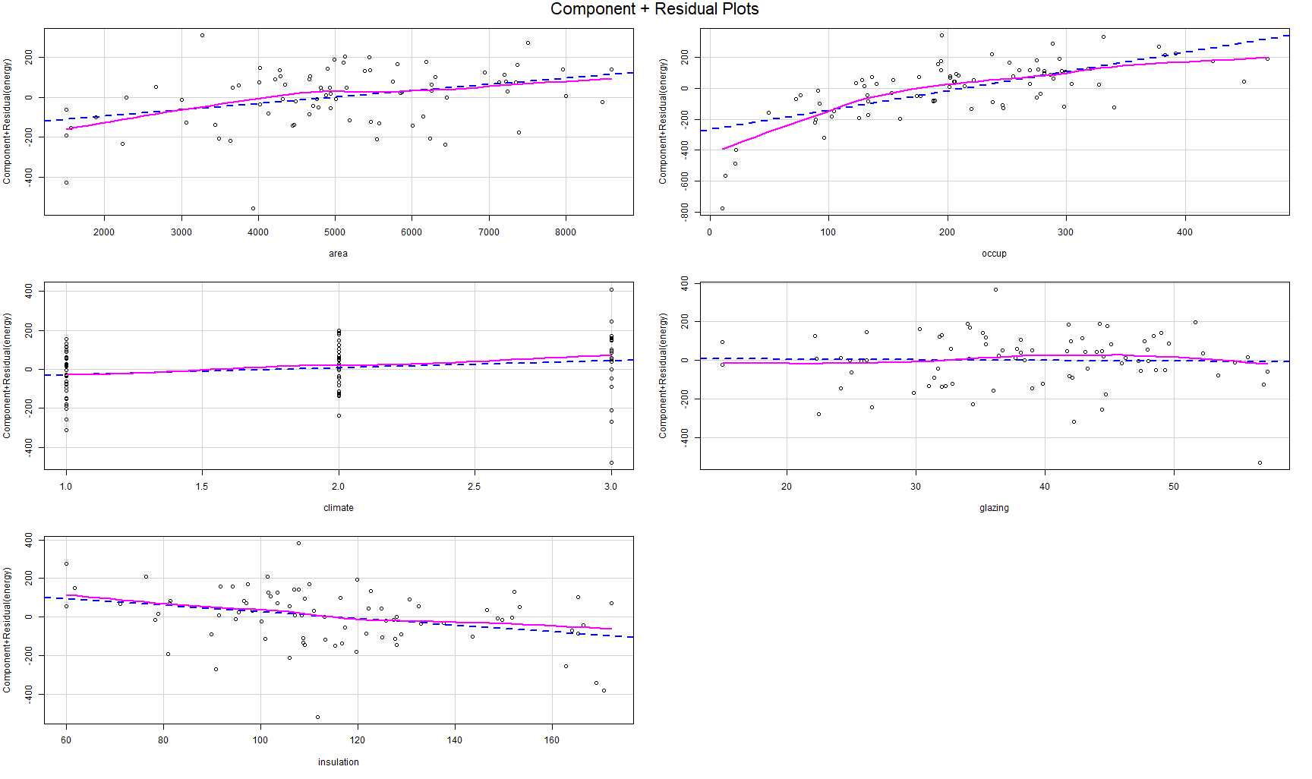

From the partial plots of the initial/original (engy_model) above, predictors, the variables area and occupancy clearly deviate from the blue dotted line which indicates non-linearity.

#### Transformed Model, Adequacy & Appropriateness of Fit

**Transformed Model 1** (engy_model2). Here the occup is log-transformed

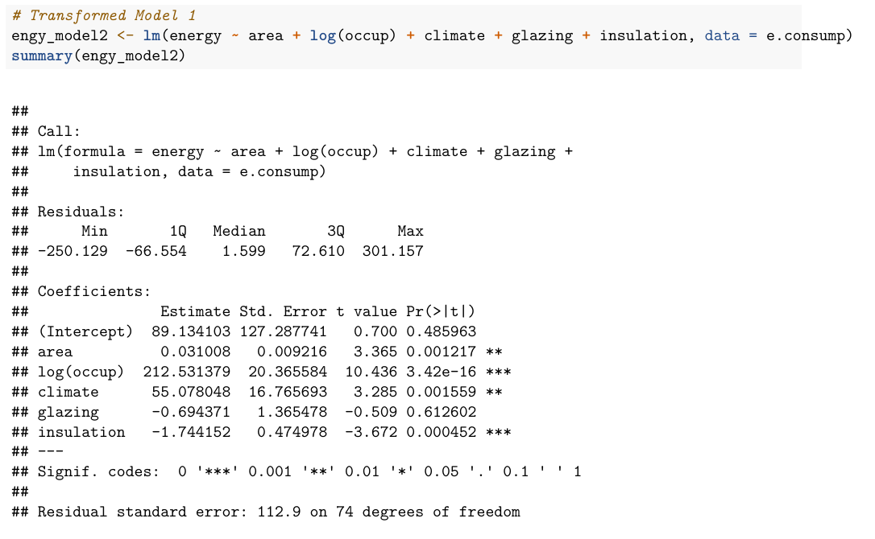

Partial Plots for engy_model2

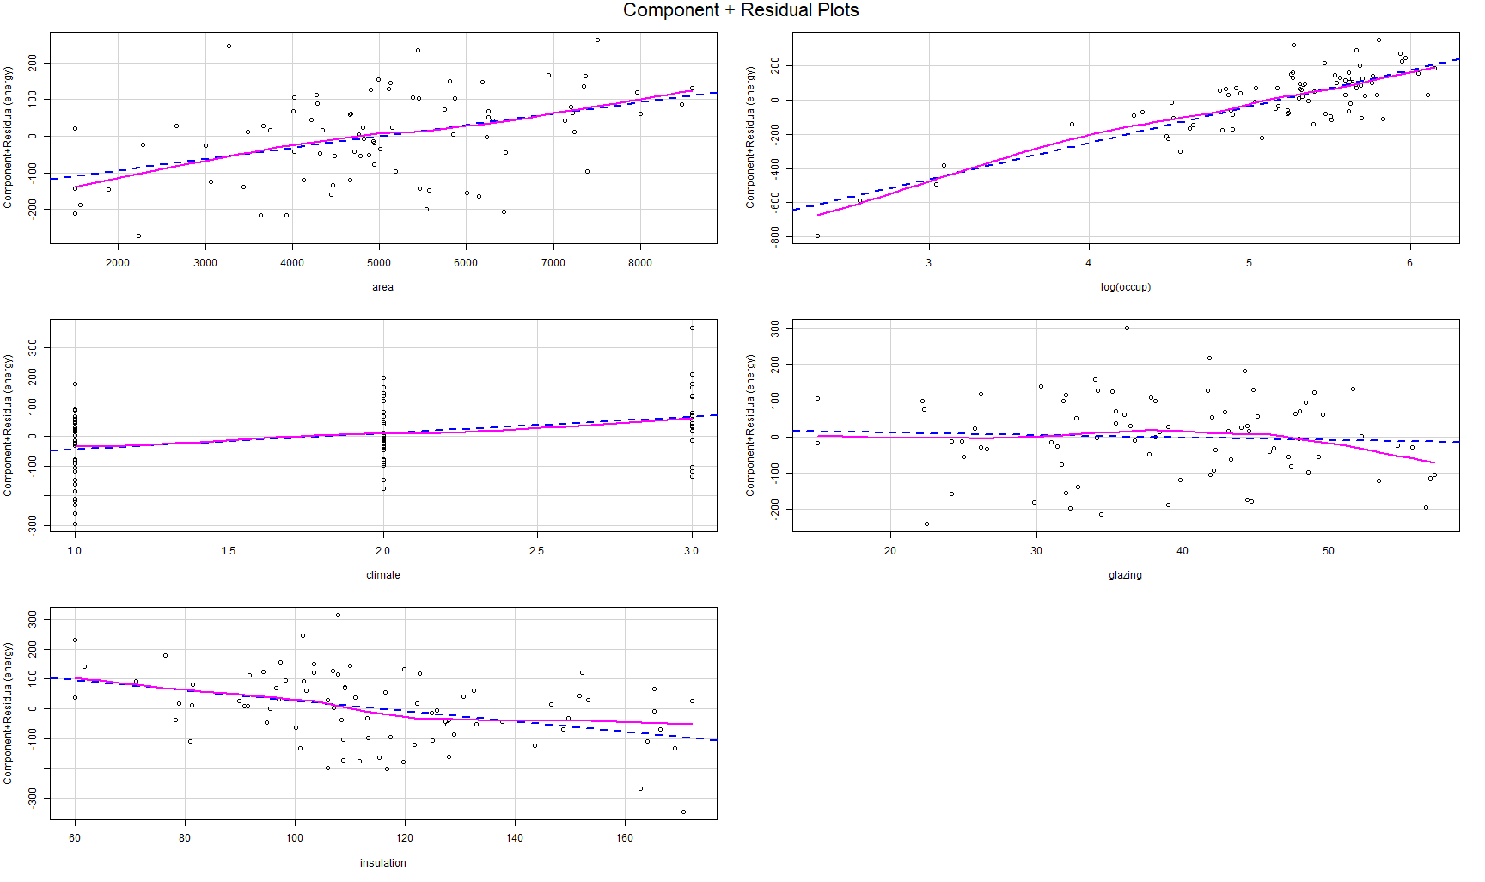

Residual Plots for engy_model2

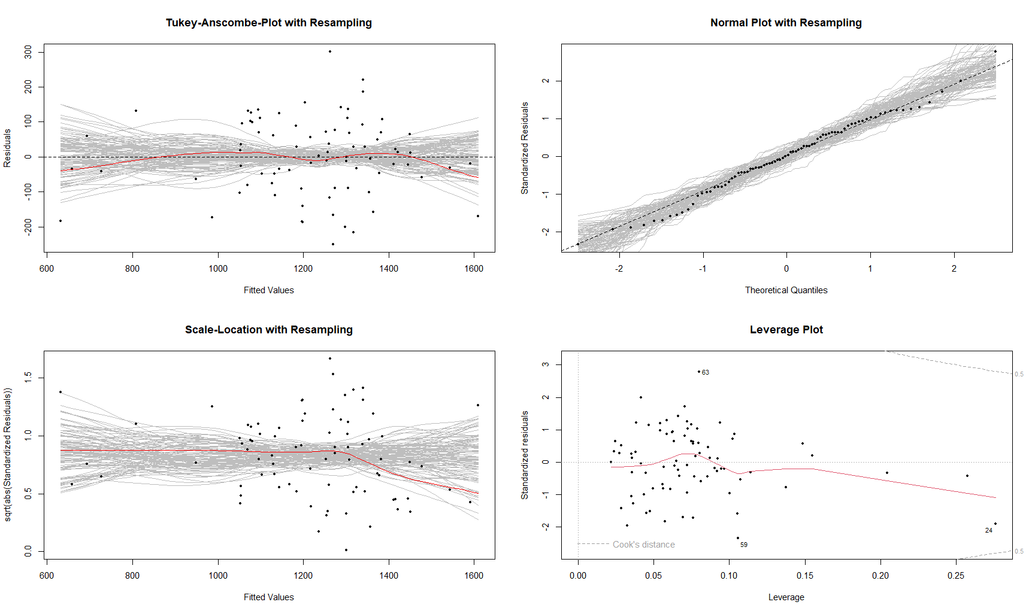

**Transformed Model 2** (engy_model3). In this model, area and occup are log-transformed

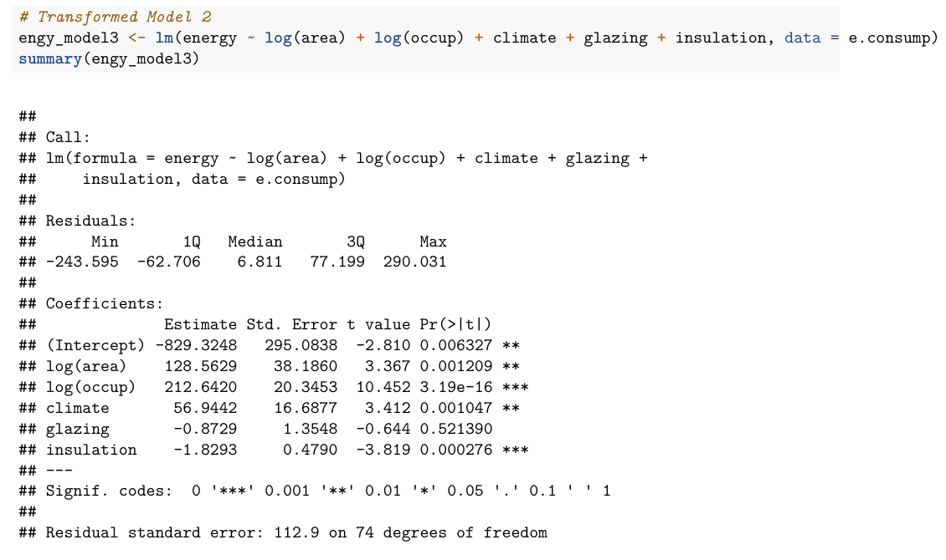

Partial Plots for engy_model3

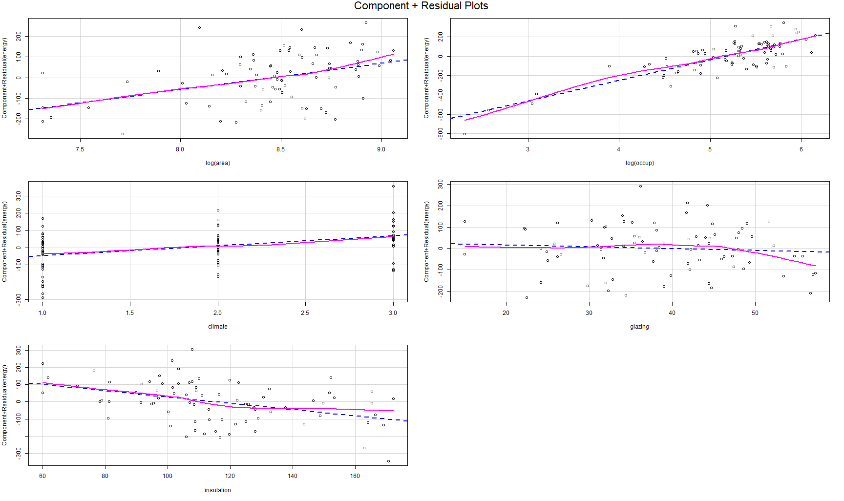

Residual Plots for engy_model3

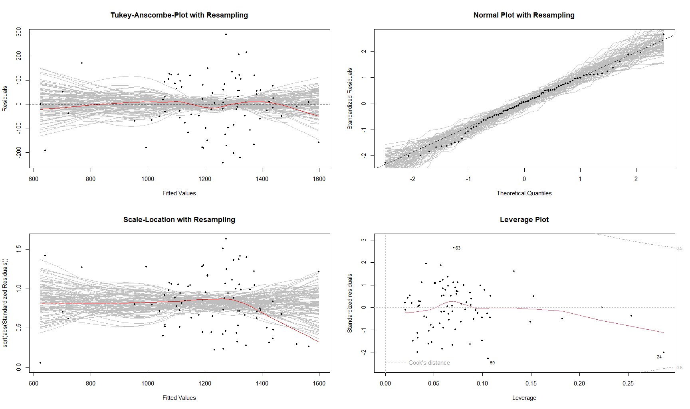

**Commenting on Model outputs, adequacy of fit and appropriateness of fit**.

In the first transformed model (engy_model2), the linearity of both variables are seen to improve. Also, the model diagnostics (appropriateness of fit) are much better for this transformed model. From the Adjusted R2, this model also fits the data better (0.7371) than the original/initial model ( 0.5774).

In the second transformed model (engy_model3), the variable linearity, residual plots (appropriateness of fit) and model fit are better than both the original and the first transformed model (engy_model2)

Therefore, this model (engy_model3), is taken as the most appropriate in this case.

### Part c): Variable Selection

Starting from the appropriately transformed model (engy_model3).

1. **Backward Elimination Model** (engy.back)



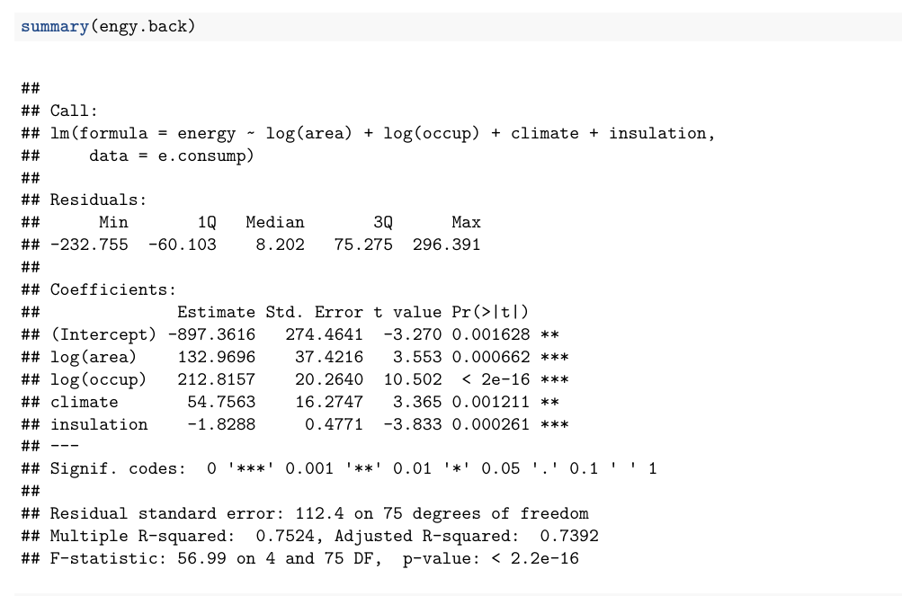

Model Diagnostics (Residual Plots) for engy.back

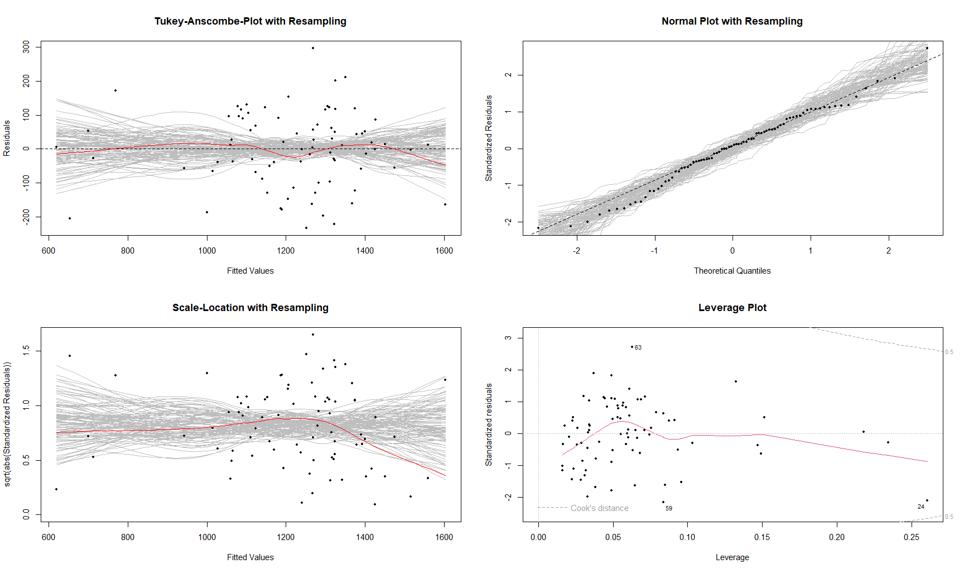

1. **AIC Stepwise Models** [engy.b1, engy.b2, and engy.b3]

Model engy.b1

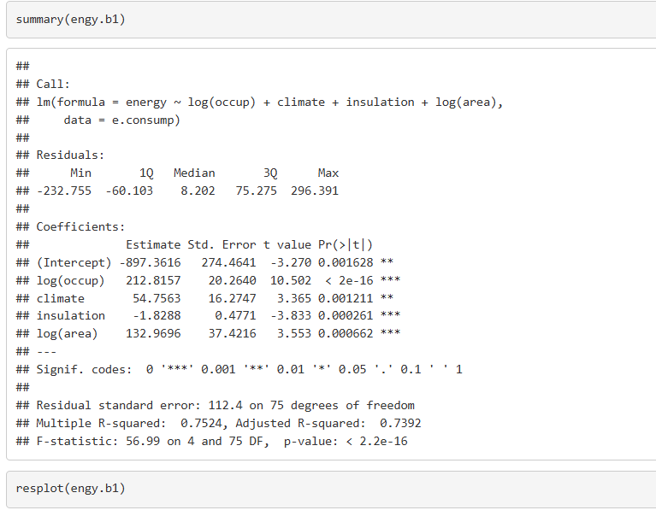

Model engy.b2

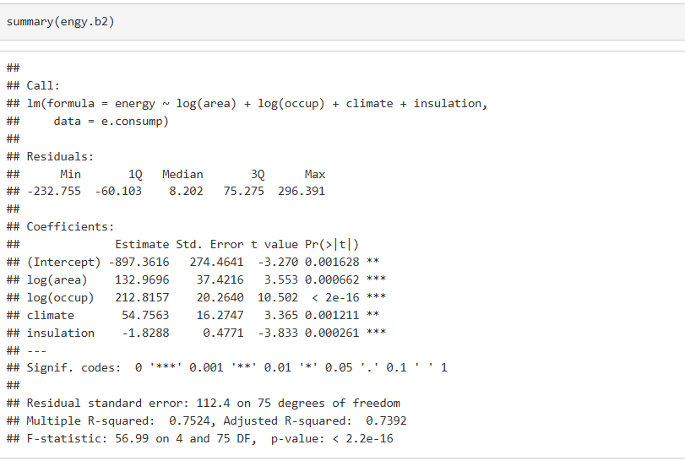

Model engy.b3

**Comparing results**

In all the reduced models from applying variable selection (i.e., engy.back, engy.b1, engy.b2 and engy.b3), the variable, glazing, was dropped.

There are no major improvements in residual plots for all the models (here, only plots for the model engy.back are shown). Also, no noticeable changes (improvements) on the remaining predictor significance or model fit as compared to the full transformed model (engy_model3).

### Part d): 5-fold cross-validation & MSPE

Compute MSPE for both the full and the reduced model. Which performs better for prediction?

**The 5-fold cross-validation loop code**

**MSPE values** for both the full and reduced models

* Full Model



* Reduced Model



* Comparing change in MSPEs (Full to Reduced)



Visualising MSPEs with Box Plots

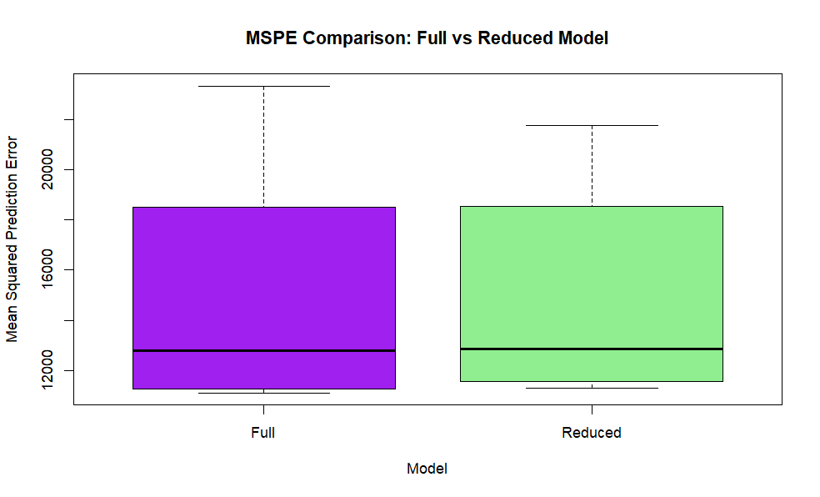

**Comparing the models**

From the cross-validation exercise, The MSPE for the *reduced* model is less (-1.275735%) than the *full* model. This implies that the variable, glazing, can be said to reduce the predictive power in model.

Thus, in this case, the reduced model is preferable for prediction purposes.

## Question 3

Multiple Linear Regression *theory questions*

### Q 3.1: MCQ Answer

**B**. Multicollinearity is present among the predictors.

### Q 3.2: MCQ Answer

**D**. Cross-validation can help compare models based on predictive accuracy

# Part 2: Analysis of Variance (ANOVA)

## Question 4

Timber bending stiffness results for 3 species

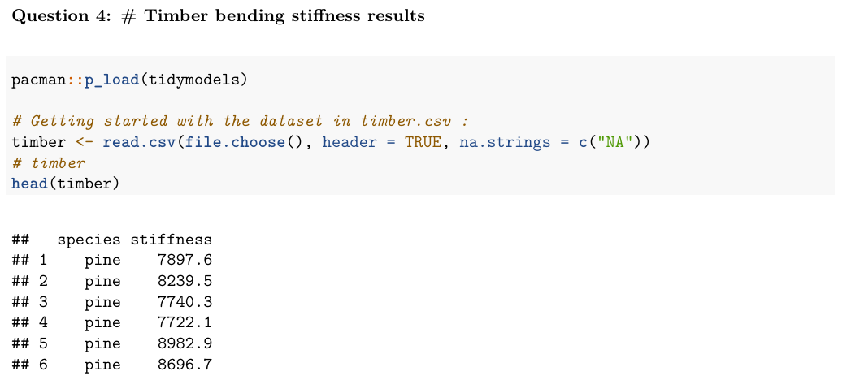

### Part a): Box Plots

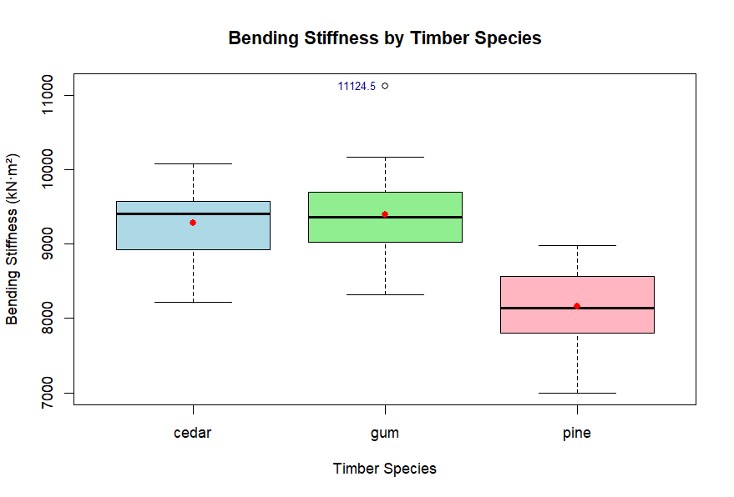

**Commenting on Variability and Outliers**

Variability

The variability of stiffness across species is assessed using the box plots and some summary statistics (standard deviation, range, and the interquartile range IQR).

As per standard deviation (SD), gum has the highest variability (607.08 kN·m²), followed by pine (506.4 kN·m²), and cedar has the lowest (505.8 kN·m²). This suggests that gum's stiffness values are more spread out compared to pine and cedar.

Comparing the interquartile range (IQR), pine has the highest IQR (728 kN·m²) which implies a slightly wider spread of the middle 50% of stiffness values compared to gum (635 kN·m²) and cedar (638 kN·m²). These differences in IQR are small and the spread central data across species is quite comparable.

The range (max - min) is largest for gum (2809.6 kN·m²), followed by pine (1983.7 kN·m²), and cedar (1854.6 kN·m²). This reinforces that gum has the most extreme values.

From the box plot, cedar has the highest median stiffness (9402.6 kN·m²), followed by gum (9365.3 kN·m²), and pine (8139.2 kN·m²) which indicates that gum and cedar generally have higher bending stiffness than pine.

Therefore, gum exhibits the highest variability in bending stiffness, as seen in its larger standard and range. This suggests less consistency in this property for gum compared to pine and cedar which have similar variability.

Outliers

From the box plot, only gum has an upper bound outlier (11124.5 kN·m²) which means it can exhibit extreme (stronger) stiffness values.

### Part b): A one-way ANOVA test

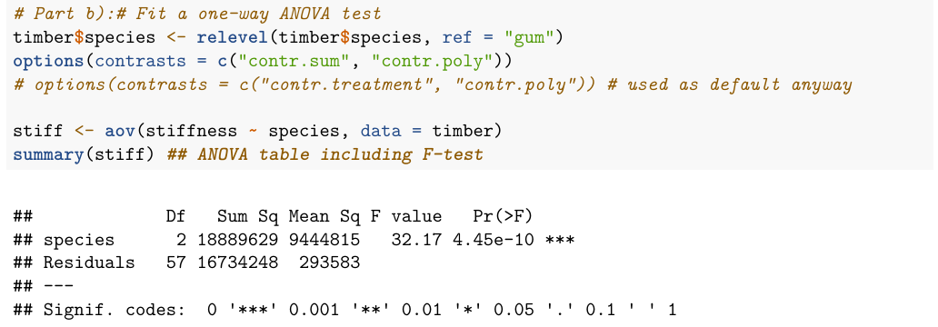

**Model Interpretation**

The null hypothesis (Ho): 𝜇pine = 𝜇gum = 𝜇cedar (All species have the same mean bending stiffness)

The alternative hypothesis (HA): At least one species has a different mean stiffness.

**F-statistic**: 32.17; This is a large F-value which indicates that between-species variability is much greater than within-species variability.

**p-value**: 4.45e-10; This extremely small (< 0.001) and so, we reject Ho at all the conventional significance levels like 0.05 and 0.01.

**Conclusion**: There is ***strong statistical evidence*** that the mean bending stiffness differs significantly between timber species.

### Part c): A pairwise two-sample t-test

A pairwise two-sample t-test (with multiple comparison correction)

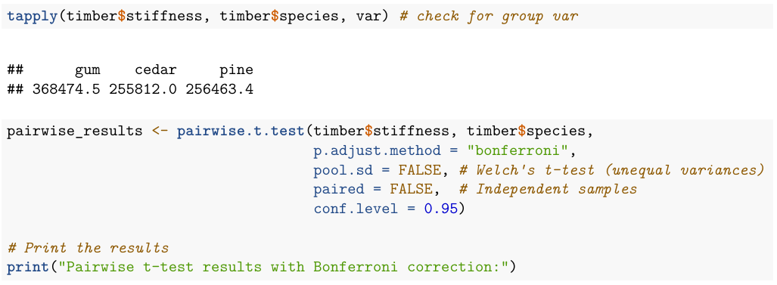

**Test Interpretation**

**Test method**: Welch-adjusted pairwise t-test because the groups have unequal variances. This adjusts the degrees of freedom for each pair according to Welch’s formula.

The *null hypothesis* (Ho): 𝜇pine = 𝜇gum [or 𝜇pine = 𝜇cedar or 𝜇gum = 𝜇cedar] (mean bending stiffness is the same) and the *alternative hypothesis* (HA): Means differ. We reject Ho if p < 0.05.

Interpretation for each pair

pine vs gum: p = 8.1e-08 < 0.05 (significant) implying that mean stiffness differs between pine and gum, hence gum is stiffer than pine (looking at raw data: gum = 9398.3 kN·m² vs pine = 8156. 5 kN·m²).

pine vs cedar: p = 6.0e-08 < 0.05 (significant) implying that mean stiffness differs between pine and cedar hence cedar is stiffer than pine (cedar = 9287.5 kN·m²).

gum vs cedar: p = 1 > 0.05 (not significant) implying that there is no evidence that gum and cedar differ in mean stiffness. Their stiffness values are roughly similar (gum = 9398.3 kN·m², cedar = 9287.5 kN·m²).

Therefore, practically, pine is the softest whereas gum and cedar have similar higher stiffness.

### Part d): Residual Diagnostics

Normal Q-Q Plot

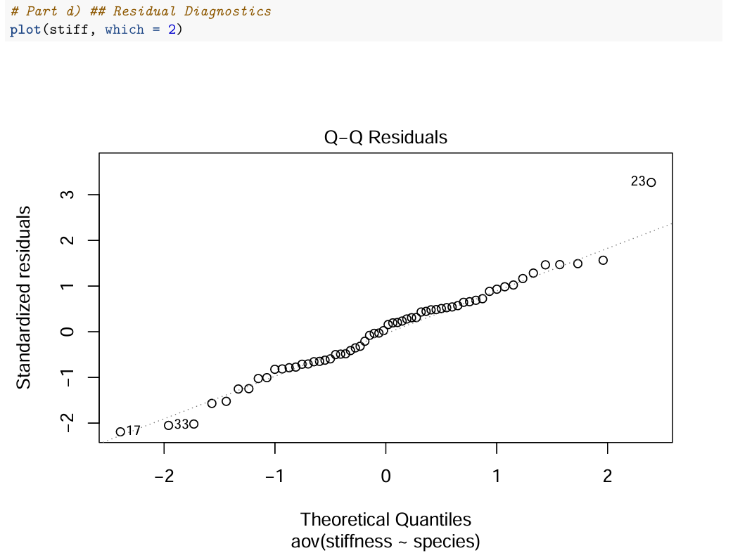

Tukey-Anscombe Plot



**Model Assumptions**

From the residual plots, error variance is constant and error can be expected to be zero (Tukey-Anscombe Plot). Errors are *i .i. d.* (from Q-Q plot). No autocorrelation is present.

The ANOVA model meets the required assumptions.

## Question 5

Compressive strength for concrete cured under different methods.

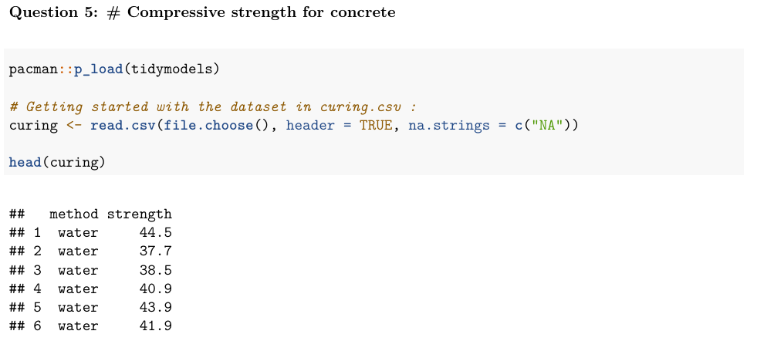

### Part a): Box Plots

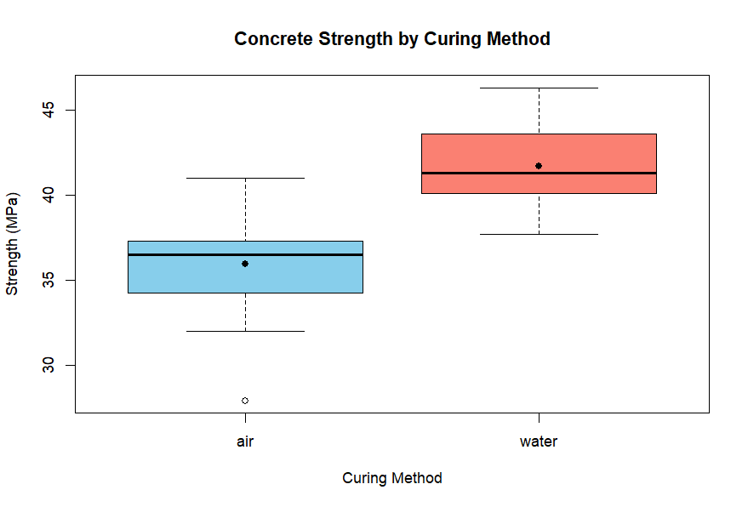

**Inspecting Difference in Strength**

From the box plots, the box for water is higher than the box for air. The Whiskers indicate that the upper range of air overlaps slightly with the lower range of water, but most water values are consistently higher.

Based on this, it appears likely that the two curing methods would produce significantly different strengths where water curing produces higher strengths than air curing.

### Part b): A two-sample t-test

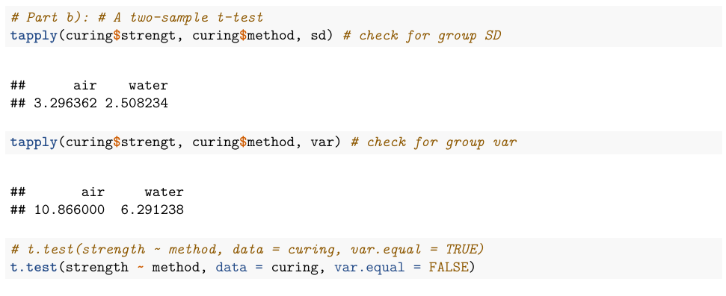

**Model Interpretation**

Test method: The Welch’s t-test (does not assume equal variances).

The ***null hypothesis*** (HO): 𝜇water = 𝜇air (mean compressive strength is the same for both curing methods).

The ***alternative hypothesis*** (HA): 𝜇water ≠ 𝜇air (mean compressive strength differs between the two curing methods).

### Part c): Test statistic, p-value, and conclusion

**Test Results**

*t-statistic*: -5.392

*p-value*: 1.178e-05

Conclusion: The p-value is much smaller than 0.05, so we reject the null hypothesis. There is *strong evidence* that the mean strengths **differ** between the two curing methods. Water curing results in significantly higher mean strength than air curing.

### Part d): Practical significance

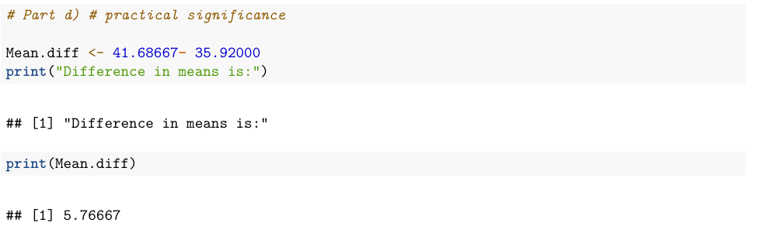

Water curing consistently produces higher strength than air curing across all samples. From the test output, the difference in mean approximately 5.8 (41.68667 — 35.920) and such an increase could be materially important in concrete performance. In construction, even small differences in concrete strength can affect structural safety, durability, or compliance with standards.

Therefore, the difference is both statistically significant (very low p-value) and practically significant because it represents a meaningful improvement in strength due to water curing

## Question 6

Analysis Of Variance theory questions

### Q 6.1 MCQ Answer

**B**. At least one species has a mean stiffness significantly different from the others.

### Q 6.2 MCQ Answer

**D**. The sample sizes must be equal.

### Q.6.3 MCQ Answer

**A**. The ratio of between-group variance to within-group variance.

### Q6.4 MCQ Answer

**B**. ANOVA avoids increasing the risk of Type I error from multiple t-tests.